Save the completed report using the following format: WFAA[MeetingName][Date][CommitteeName].doc. Submit your report via email to the WFAA Executive Council and post your report to the WFAA website’s Meeting Minutes Index no less than 4 days prior to meeting.

WFAA Quarterly Officer/Committee Report 2018 - 2019
Executive Council Meeting Date |  |  | May 29 – May 30, 2019
 |  |  | WFAA Transition Meeting

Officer/Committee Information
Office Held/Committee Name: |  |  | Membership Chair
Officer/Committee Chair: |  |  | Tammy Zibell

Officer/Committee Goals for Service Year
Strategic Plan Goals that are being met (check all that apply)
Goal 1: Be a leader in providing training and professional development opportunities that are responsive to member needs
Goal 2: Maintain the long-term financial stability of the Association
Goal 3: Assess and monitor the performance of the Association and implement strategic Adjustments
Goal 4: Increase member participation in Association activities |  |  |  |  |  | X
Goal 5: Continually improve methods and processes for communicating with the membership |  |  |  |  |  | X

Goal 6: Consolidate and communicate the public policy positions of financial aid administrators in Washington State and provide members with support and education to further their own advocacy efforts

Goal 7: Maintain and enhance the diversity of our membership and the Executive Committee
Goal 8: Collaborate and coordinate with other organizations and associations in order to serve our members more efficiently and effectively |  |  |  |  |  | X
Specific Officer/Committee Goals (Include progress toward goals and measurement of success.) |  |  | - Increase member participation.  - Familiarize myself with Membership procedures and create written procedures for others to follow.

Summary of Activities (Descending Chronological)
May 2 – 10, 2019 – Reviewed training materials on how Membership Automatic Renewal process works and steps needed to be done prior to new reminders going out.

May 22, 2019 – We have 2383 Current Members

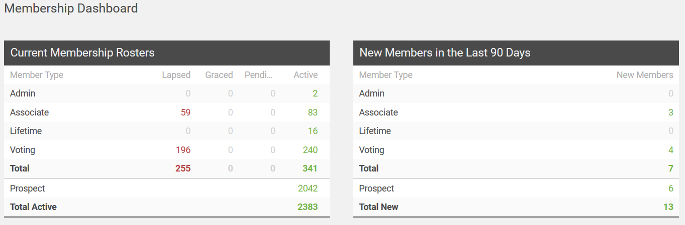
May 22, 2019 - Reviewed Member Clicks Training Videos

https://help.memberclicks.com/hc/en-us/sections/206664928-Setup-and-How-to-Videos

May 24, 2019 – Confirmed with Robert Clarke our Authorized Service Administrator that we were set up to do our 1st Renewal Membership Automation. Our Renewal membership notice is schedule to go out on May 30, 2019. I will monitor this and fix any issues that could come up because it is so new. Also, I will send out a 2nd renewal reminder around June 15, 2019.

i
Budget Information
Approved Budget |  |  | N/A
Budget Expenditures to Date |  |  | N/A
Event Information (complete if applicable) |  |  | N/A
Event Name
Location
Date
 |  |  | Number | Cost of Registration | Subtotal
Attendees
Complimentary Registrations (if applicable – i.e., scholarship recipients)
Add more rows as needed for additional events.

Suggestions for Future Officer/Committee
Continue to find ways to increase WFAA Membership

Calendar of Events/Timelines
Date | Committee Member Responsible | Description

