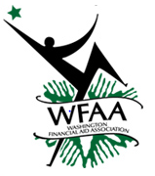
At the Yakima Convention Center in Yakima, WA
October 10-12th, 2018
Investing in others to make a Difference
2018 WFAA Annual Conference

This year’s conference will be located in the beautiful town of Yakima at the Yakima Convention Center. The conference will give you an opportunity to not only develop as a professional, but to network and explore the wonderful Valley of Yakima. This year’s agenda will include presentations from our regional (WASFAA) and national (NASFAA) professional organizations, as well as interest sessions from federal and state leaders. The keynote speech on Wednesday, October 10th, will be from Roger Fernandez, a Native American Artist and storyteller.
Roger Fernandes, or Kawasa, as his fellow members of the Lower Elwha Band of S'Klallam Indians near Port Angeles call him, has strong feelings about how stories should be shared.

"The true power of storytelling comes when the moisture of the teller's breath gives life and power to the story," Fernandes says.

This Year’s Interest Sessions will Include Presentations on:
- Loan Limits: Why They matter | - Scholarship Transformation and Revitalization (STAR) Team | - Everything You Need to Know About the Washington State Opportunity Scholarship
- Students and Credit | - Facilitated Discussions on Planning for the Year Ahead | - WSAC Real Time Processing, Interim Report (Including Final) and Year End Closeout
- VA Benefits | - The More Things change… Comment Codes 400 & 401 | - Financial Aid is an Umbrella-Type of Financial Aid and Other Ways to Pay for College
- Verification | - Supporting Undocumented Students- Financial Aid & More | - How Are You Really Doing? Stress, Mental Health, and Self-Care for Higher Education Professionals
- Adult Reengagement | - “I’ve never heard that one before” – Troubleshooting Financial Aid | - College Savings Plan Updates- Understanding the GET and Dream Ahead College Savings Plans
- SB5100: One Year Later | - WSAC & Satisfactory Academic Progress Pilot | - Dissecting the FAFSA and the New MyFAFSA Mobile App
- Financial Aid Jeopardy | - Becoming Efficient and More Effective | - Comparing Financial Aid Award Letters and Understanding Cost of Attendance
- Special Funding | - PeopleSoft Business Process Best Practice | - SULA: 150% Subsidized Loan Limitation

Please join the Western Association of Financial Aid Administrators (WASFAA) for a special pre-conference training session.
Wednesday, October 10 from 8:00 am to 12:00 noon
You Said What?! Effective Communication Tools A-SAP
Learn and practice new skills to assertively communicate and negotiate in critical situations. Session includes Satisfactory Academic Progress (SAP) NASFAA-U credential preparation, the NASFAA-U SAP study guide, and a voucher to take the test for your NASFAA credential.
Cost: $35 for current WASFAA members, or $85 for non-members (includes a WASFAA membership).
*Please note that this is valued at over $600 if purchased directly through NASFAA
Registration is separate from the conference. Please register here: https://www.wasfaa.org/docs/forms/1819_PrePostConferenceTraining.html

SPECIAL PRE-CONFERENCE TRAINING:
- Looking for a little gambling? Stop by the Caribbean or Legends Casino!

THINGS TO DO IN THE AREA:

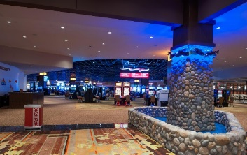
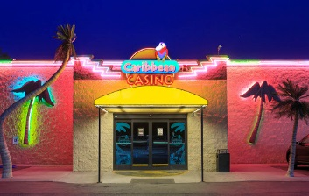

- Enjoy golfing? Visit the Sun tides Golf! Course

- Love Wine? Visit one of our many Wineries!

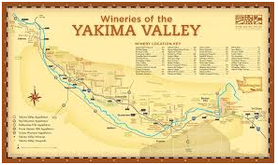
HOTEL RESERVATION INFORMATION:
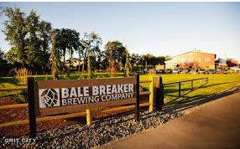
- Or if you’re more of a beer person, we also have many breweries!

Make your reservation for the Holiday Inn by September 14th. Call in and mention the WFAA Conference 2 to get the rate below.

The Holiday Inn conference rate is $149, plus taxes and charges.
Check-in begins at 3 p.m. and ends at 12 p.m. Reservations can be made by calling the hotel directly at (509) 494-7000 just give the WFAA Conference name and dates. Breakfast not included. 2-minute walking distance to Conference.
Free parking available.
Complimentary Wi-Fi, fitness center, and indoor pool are included.

