Save the completed report using the following format: WFAA[MeetingName][Date][CommitteeName].doc. Submit your report via email to the WFAA Executive Council and post your report to the WFAA website’s Meeting Minutes Index no less than 4 days prior to meeting.

WFAA Quarterly Officer/Committee Report 2017/2018
Executive Council Meeting Date |  |  | October 12, 2018
 |  |  | Yakima Convention Center

Officer/Committee Information
Office Held/Committee Name: |  |  | Membership Chair
Officer/Committee Chair: |  |  | Tammy Zibell

Officer/Committee Goals for Service Year
Strategic Plan Goals that are being met (check all that apply)
Goal 1: Be a leader in providing training and professional development opportunities that are responsive to member needs
Goal 2: Maintain the long-term financial stability of the Association
Goal 3: Assess and monitor the performance of the Association and implement strategic Adjustments
Goal 4: Increase member participation in Association activities |  |  |  |  |  | X
Goal 5: Continually improve methods and processes for communicating with the membership |  |  |  |  |  | X

Goal 6: Consolidate and communicate the public policy positions of financial aid administrators in Washington State and provide members with support and education to further their own advocacy efforts

Goal 7: Maintain and enhance the diversity of our membership and the Executive Committee
Goal 8: Collaborate and coordinate with other organizations and associations in order to serve our members more efficiently and effectively |  |  |  |  |  | X
Specific Officer/Committee Goals (Include progress toward goals and measurement of success.) |  |  | - Increase member participation.  - Familiarize myself with Membership procedures and create written procedures for others to follow.

Summary of Activities (Descending Chronological)
June 11- 30 2018 MemberClicks Training and creation of Welcome Letter for WFAA Members.

July 17, 2018 – Sent email to WFAA Members reminding them about summer training.

July 17 – 23 – Worked on Membership clean up from old system to new system.

July 24, 2018 – Sent 1290 Welcome to MemberClicks email letters to all WFAA members past and present.

August 3 - 16, 2018 – Continued with Membership clean up by removing duplicate profiles, deleted profiles that had only a name and no school and/or contact information. Familiarizing myself with forms, reports etc. on new website.

September 20, 2018 – Sent WFAA Volunteer List to Conference Chair.

October 5, 2018 - Current Membership Dashboard – Total 295; includes 3 admin, 74 Associate, 16 Lifetime, 202 Voting.

October 5, 2018 – New Members in last 90 Days 50.

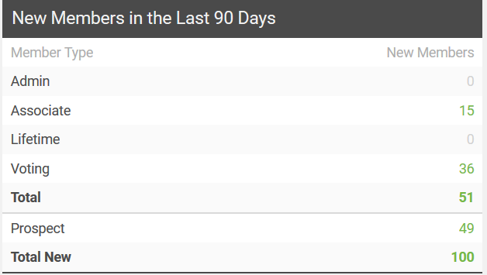

October 5, 2018 – Ran Profile Roster for all WFAA Members that had renewed membership for 2018 and had a total of 167

***DISCREPANCY WITH DASHBOARD NEEDS TO BE RESEARCHED***
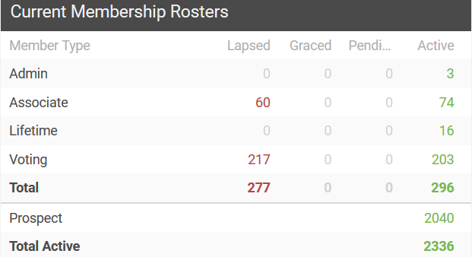

According to the Profile Roster all past and present members have an ACTIVE member status which is a total of 2336

i
Budget Information
Approved Budget |  |  | N/A
Budget Expenditures to Date |  |  | N/A
Event Information (complete if applicable) |  |  | N/A
Event Name
Location
Date
 |  |  | Number | Cost of Registration | Subtotal
Attendees
Complimentary Registrations (if applicable – i.e., scholarship recipients)
Add more rows as needed for additional events.

Suggestions for Future Officer/Committee
Continue to find ways to increase WFAA Membership

Calendar of Events/Timelines
Date | Committee Member Responsible | Description

