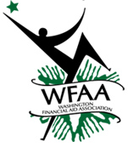
WFAA Summer Training Workshop 2018
Tuesday, July 31st

Thank you to our host:
Divers Institute of Technology
1341 N Northlake Way, Suite 150
Seattle, WA 98103

Agenda

8:30-9:30 am – NASFAA University Satisfactory Academic Progress

9:30-9:40 am – 10 min break

9:40-10:40 am - NASFAA University Satisfactory Academic Progress

10:40-10:45 am - 5 min break

10:45 – 11:45 am – Washington Student Achievement Council State Update

12:00 – 1:30 pm – Lunch (no host options available on website)

1:30 – 3:00 pm – Department of Education Federal Update

*See website for Parking and Lunch options.

